**A Web Application Project for Industrial Training under Ogma TechLab**

**Title:-** CollExplore(College Explorer) – A Web Application Purely made for Students.

**Project Report By**

Partha Bhowmick

Mihir Gupta

Mouli Mondal

Sumit Mandal

Alangkrita Sarkar

Prajesh Bandhu Banerjee

**Under Supervision of**

Mr. Amar Banerjee



**Ogma TechLab, Kolkata**

**&**

**Government College of Engineering and Ceramic Technology, Kolkata**

**Topic:-** CollExplore(College Explorer) – A Web Application Purely made for Students.

**Introduction:-**

CollExplore(College Explorer) is a web-based platform that helps students from across India explore and discover colleges as well as predict colleges based on their score. Our product lets students from across India explore and discover colleges, as well as predict colleges based on their score with the help of our premium feature like College-Predictor. Any Student can even maintain a profile by creating their account on our website in order to use Premium Features from this Website. With our platform, any student will be able to see all the colleges in different area(s), find out about the location, placement rating, infrastructure, fees and other relevant details, get information about how to apply for admission and more. One can use this information to make an informed decision about which college or university would be suitable for oneself.

**Objective:-**

CollExplore has been purely made with an objective to help students get acknowledged with precise information about any Engineering College across whole India, they want to get admission in or simply get to know which colleges they can probably get admission in through College-Predictor.

**Technical Stack Used:-**

* **Database:-**
  + MySQL
* **Front-End:-**
  + HTML 5
  + CSS 3
  + Angular Framework (version 14)
* **Back-End:-**
  + Node JS (Version 16)
  + Express JS Framework (version 4)

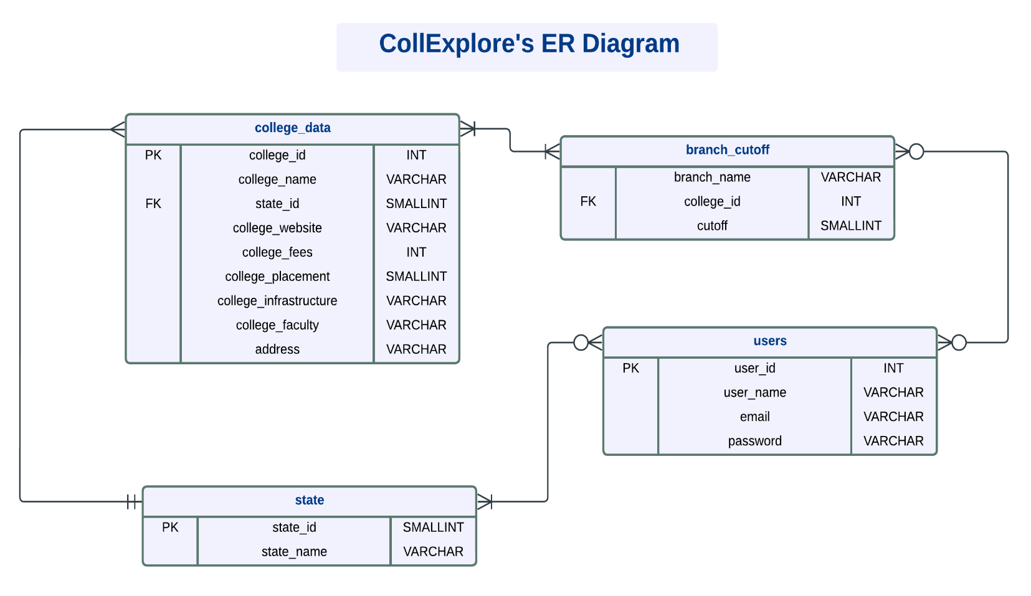**Database Structure:-**

**>> Symbols Used and Their Meanings:-**

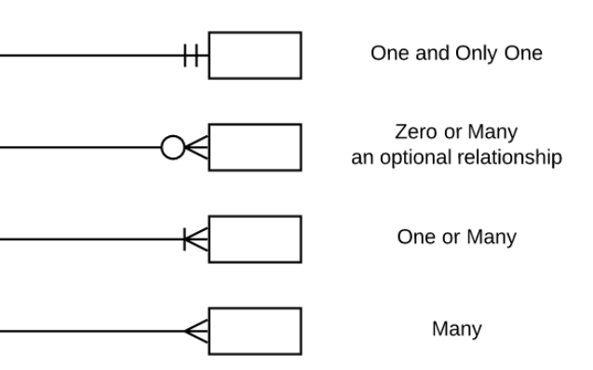

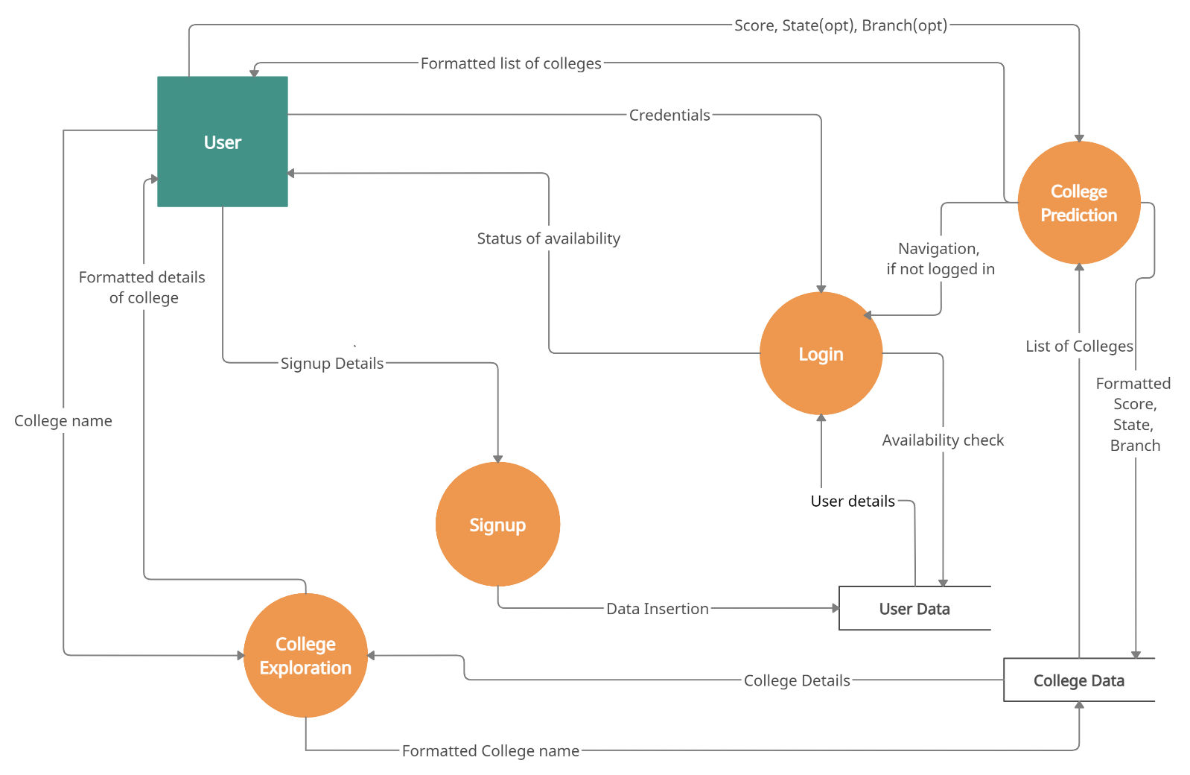**Data Flow Diagram:-**

** The above diagram sums up how does data flow whenever an “User” enters this web application any moment.

**Explanation:-**

1. 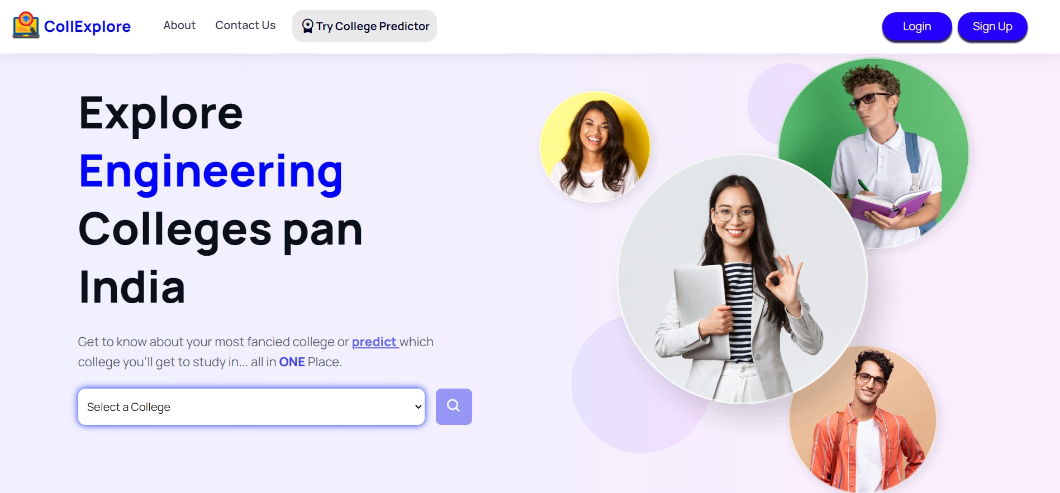**Landing Page:-** Whenever a user enters our website he/she will land on this Home Page as shown below:-
2. A User can explore colleges without logging in/creating an account, so any user who want to implement the same can select any college from the given dropdown list as shown below:

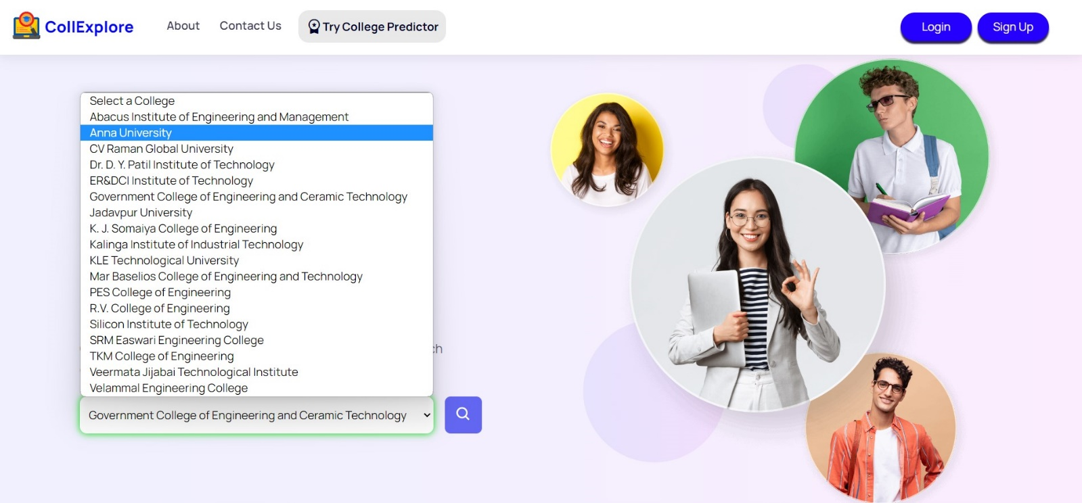

* 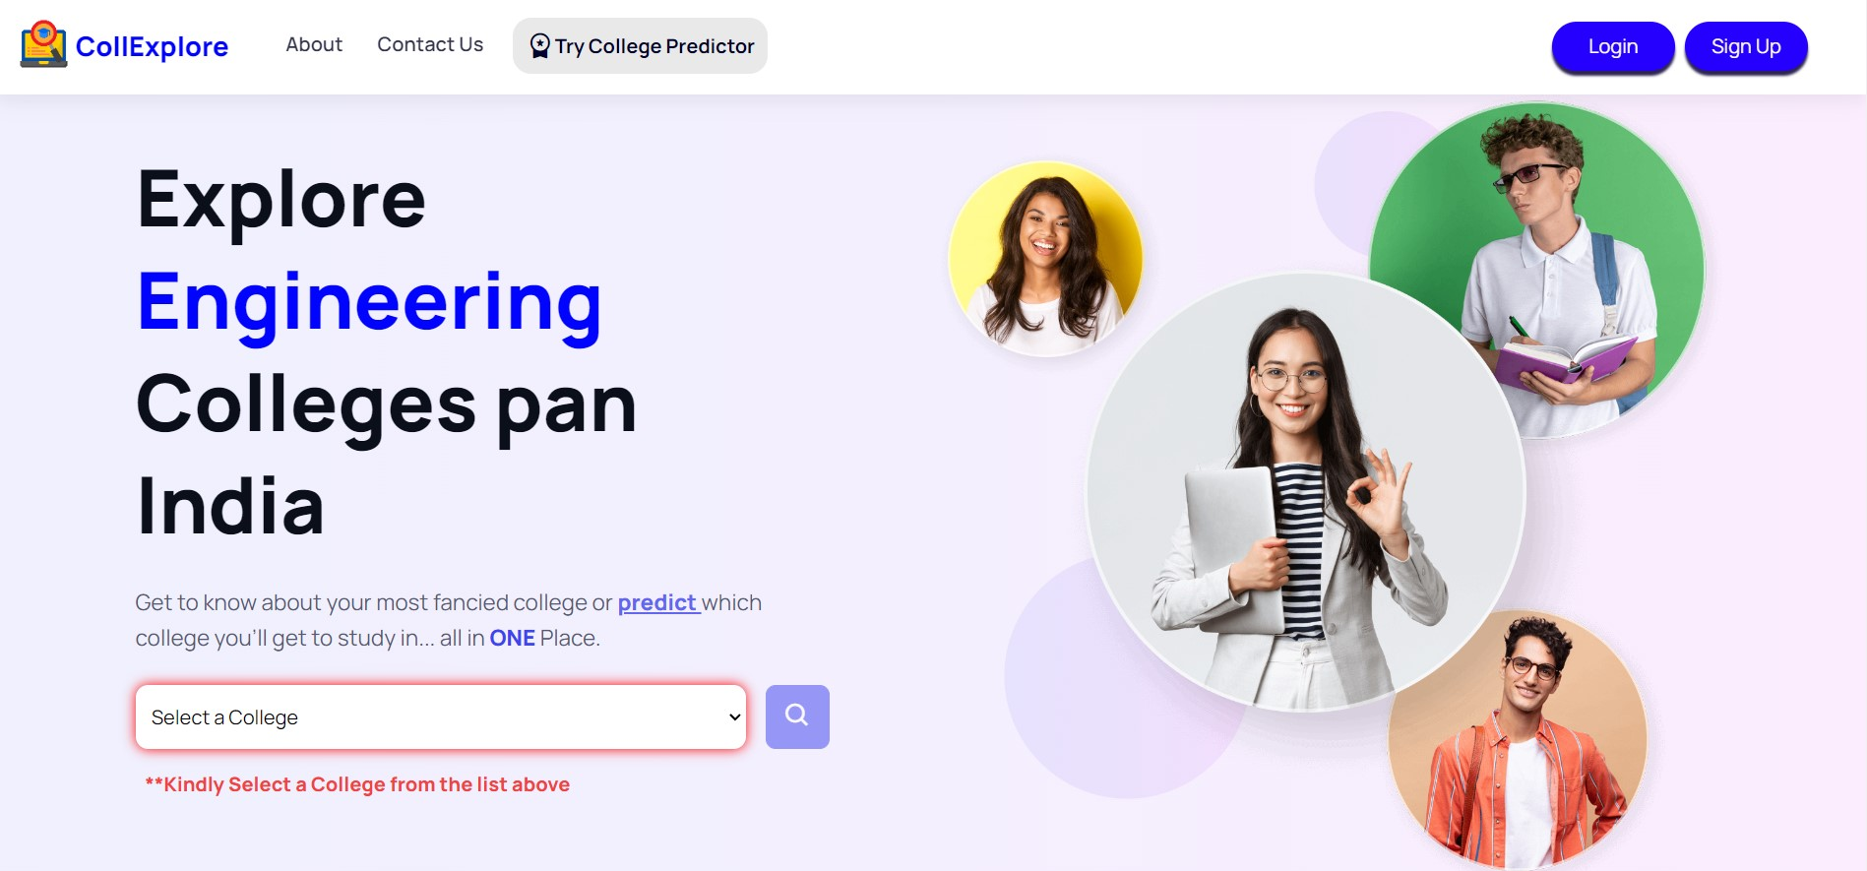If user doesn’t select any college then, it will display a **message requesting** the user to select a college from the list:
* Otherwise, a **GREEN** border signifying Success will be displayed:

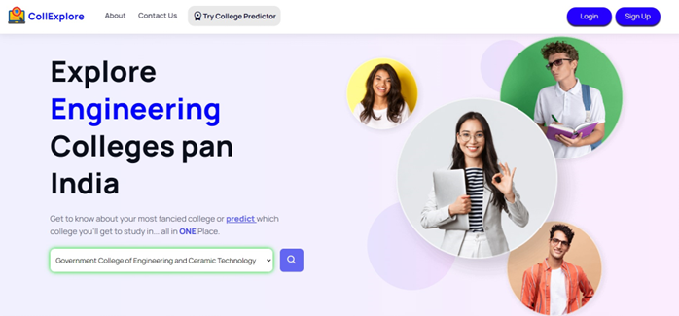

1. Finally, **SEARCH** button is enabled after successfully selecting a college from the list and one will be automatically Scrolled down to a box where all the required and precise information about the selected college is displayed, as shown below:



1. **Login/Signup:-** Now, in order to use College Predictor, an user will either need to login into their account or create an account. Without Logging In or Signing Up, no user can experience College Predictor Feature in any way as it is evident from the visuals below:

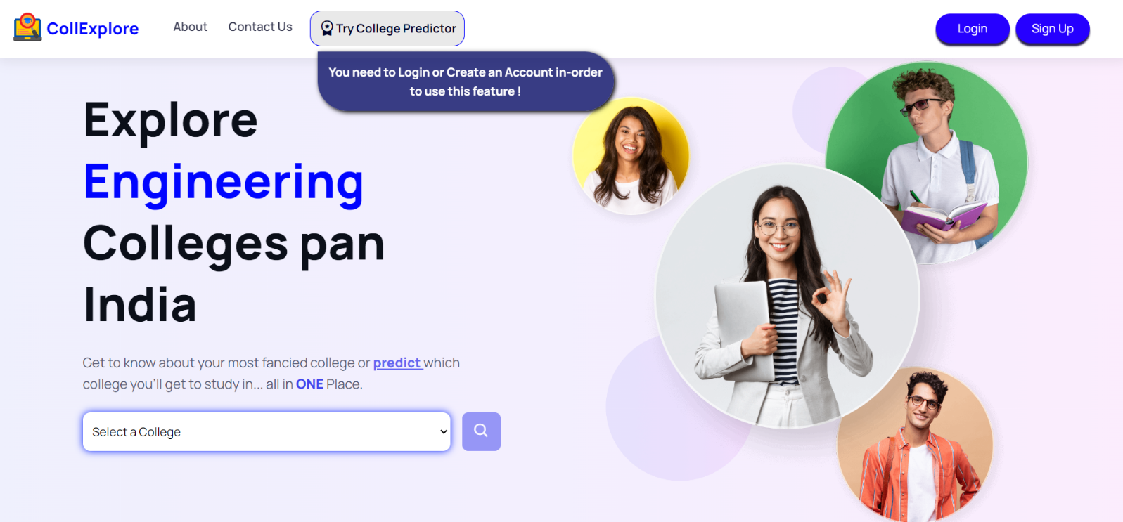

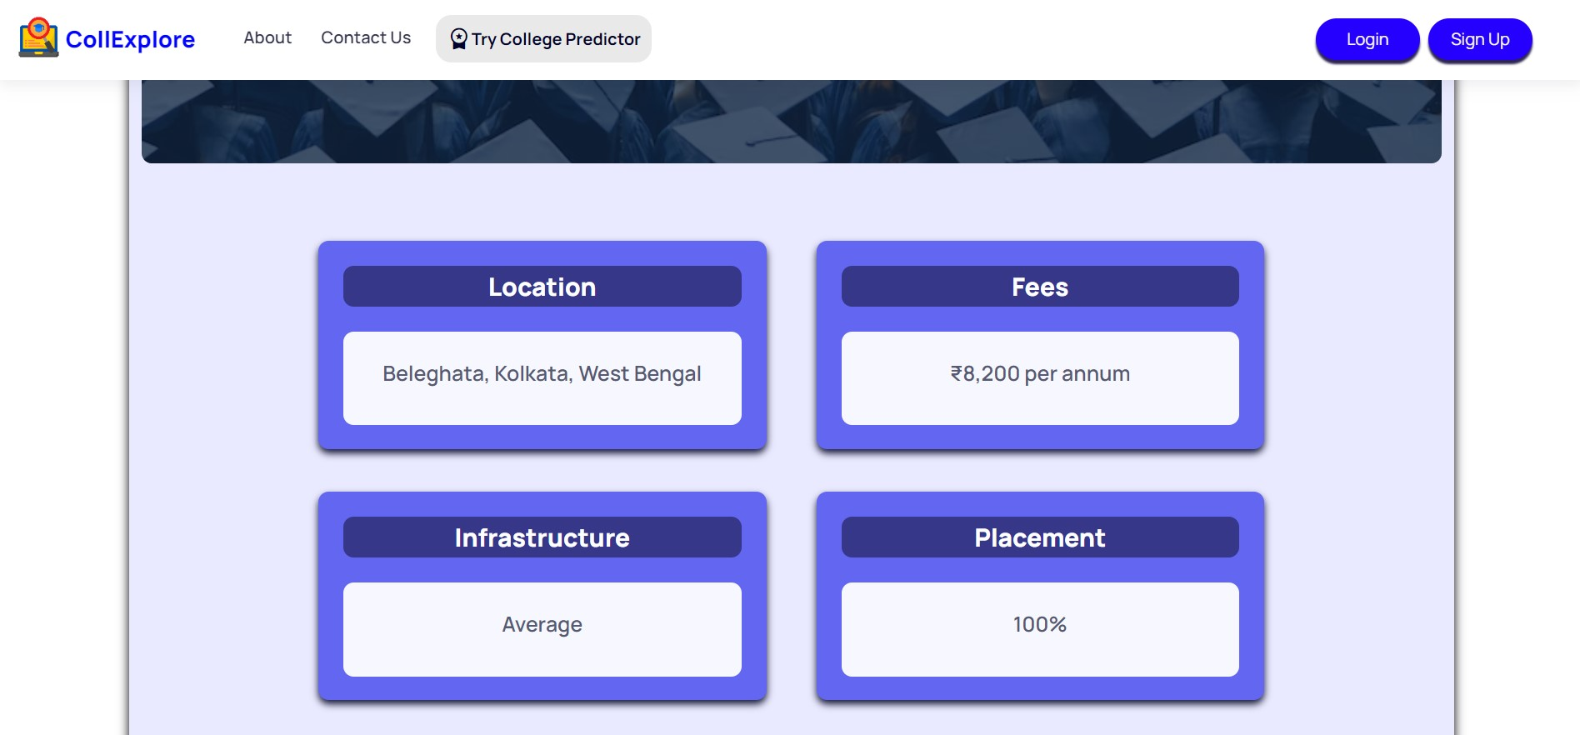

* So, for this very reason let’s have a look at how our Sign Up form Works:-

1. Firstly, whenever any user clicks on the ‘**Sign Up’** Button on the navigation bar, a form asking for some details will be displayed as shown below, where a user will input his/her data and it will directly go into ‘users’ database.

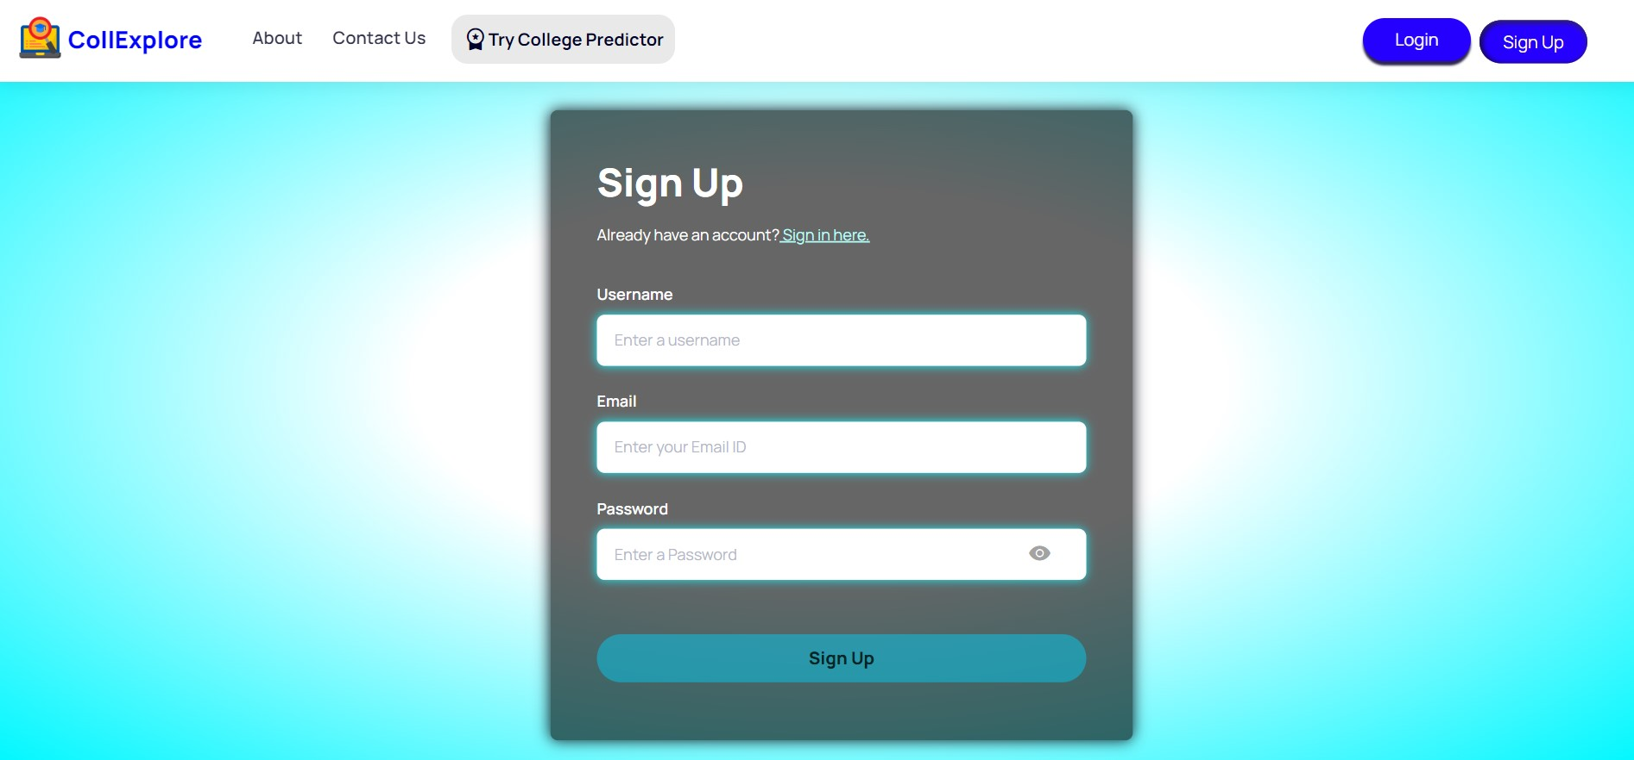

** The blue border signifies that a user hasn’t touched any part of the form yet, no detail has been entered.

1. An **error** message will be displayed if user have visited a particular field but left it empty as shown below and for the same **RED** Border will be toggled:

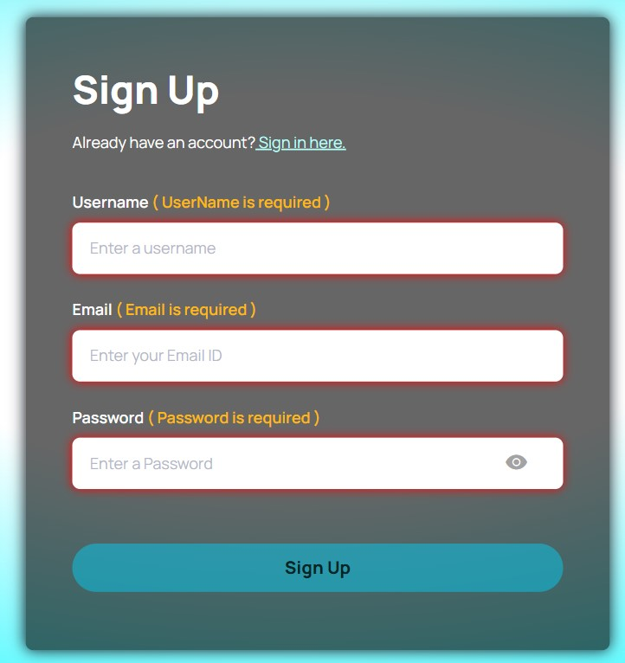

1. A **Green** Bordered field will get toggled up if any user has successfully entered all the details in the respective fields and because of which now, **Sign Up** button is also enabled:

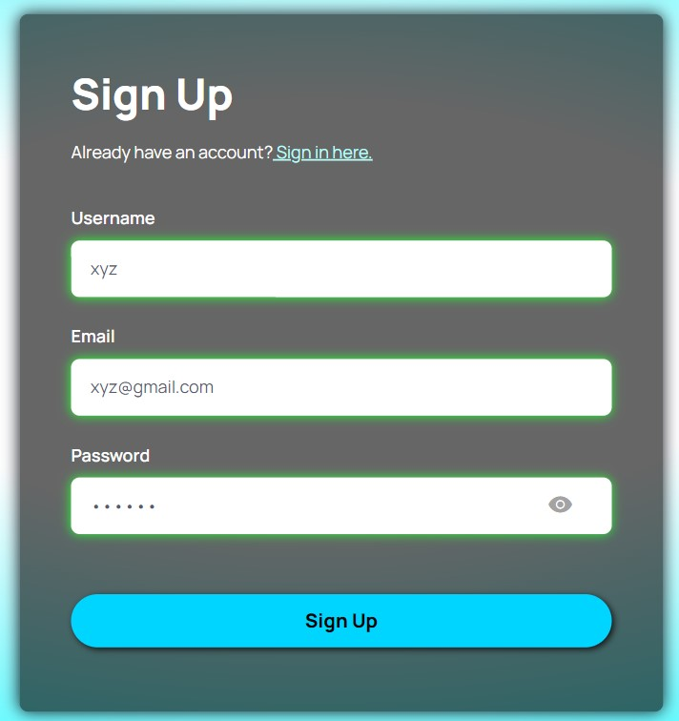

1. 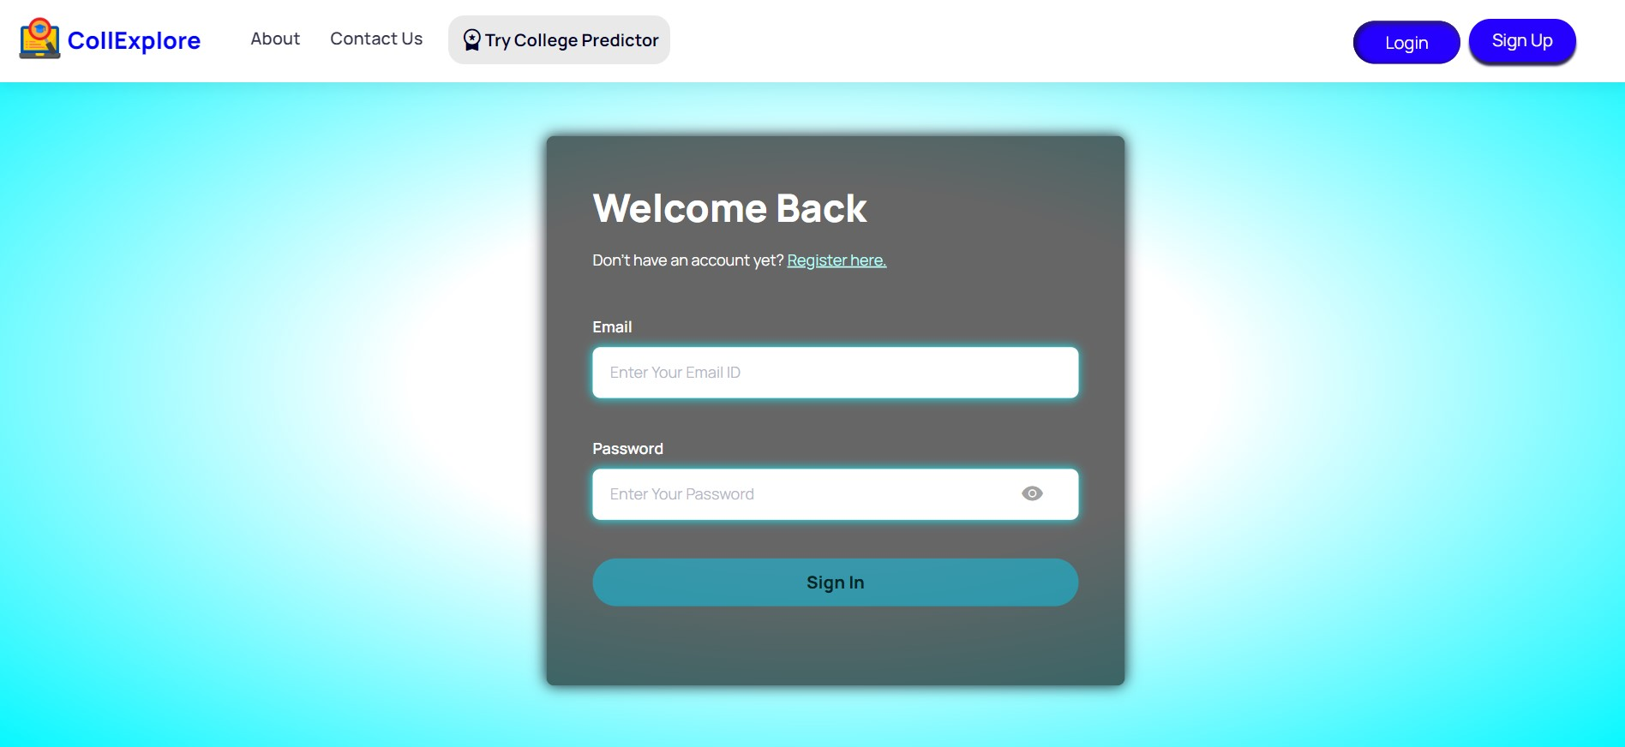Similarly, if any user already has an account then, he/she can enter their respective login credentials by navigating to Login Form page through **Login** Button present on the Navigation Bar:-

** Here, also, Red, Green and Blue borders will get toggled up for same reason as Sign Up Form

1. There can be “two” scenarios if any user logs into their account(s) :-
   * User entering **incorrect login credentials** will be notified with an error message in the form itself, the **Green** tick signifies that user has entered some input but it is invalid which is evident from a **Red** Border as shown below:

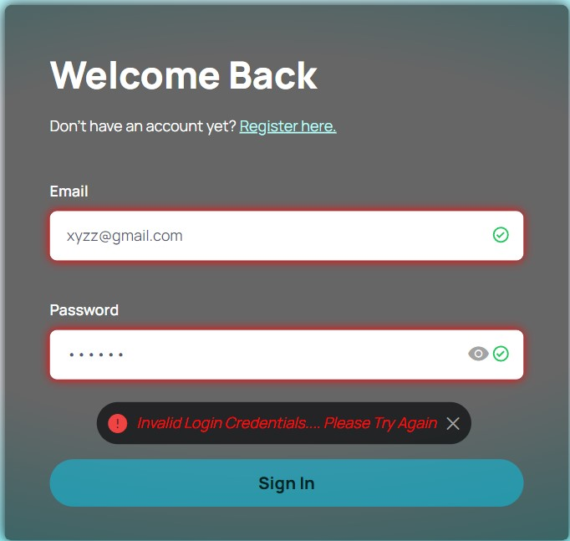

* + 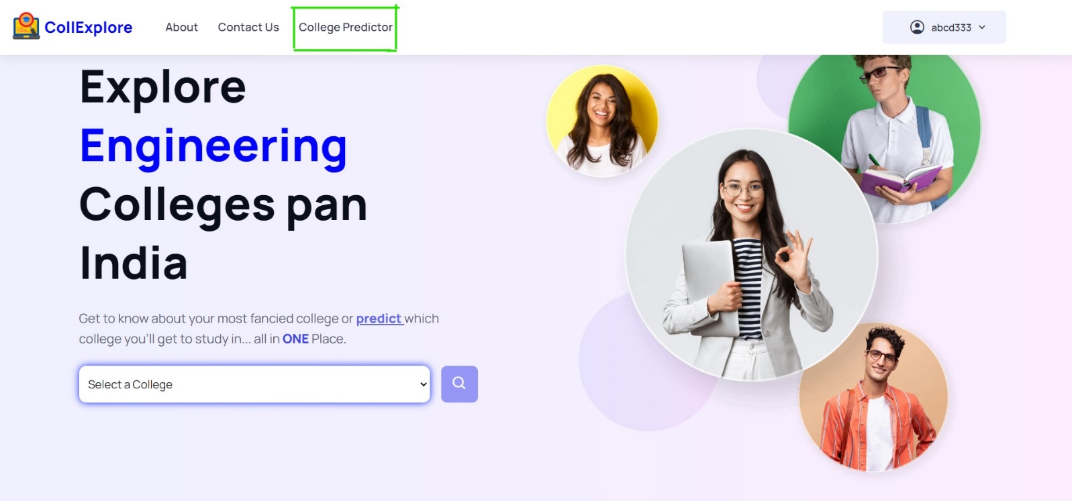And if user enters Correct Credentials, then that ‘Sign In’ button will get enabled and on clicking it user will redirected to Home Page where they will get to see **College Predictor** tab as well as their username in the navigation bar:

1. **College Predictor:-** A form with three fields will be displayed on visiting this tab where a user will be asked to enter his/her JEE Score ranging between 0-360 which is compulsory to enter. Whereas other two fields are not mandatory but a user can also enter State or Department/Branch or both along with their Score. Output will be in form of a TABLE consisting of Details of different colleges and if there are no output then a message telling “No Results Found” will be displayed. The Outputs for different scenarios are shown in the below visuals:

* 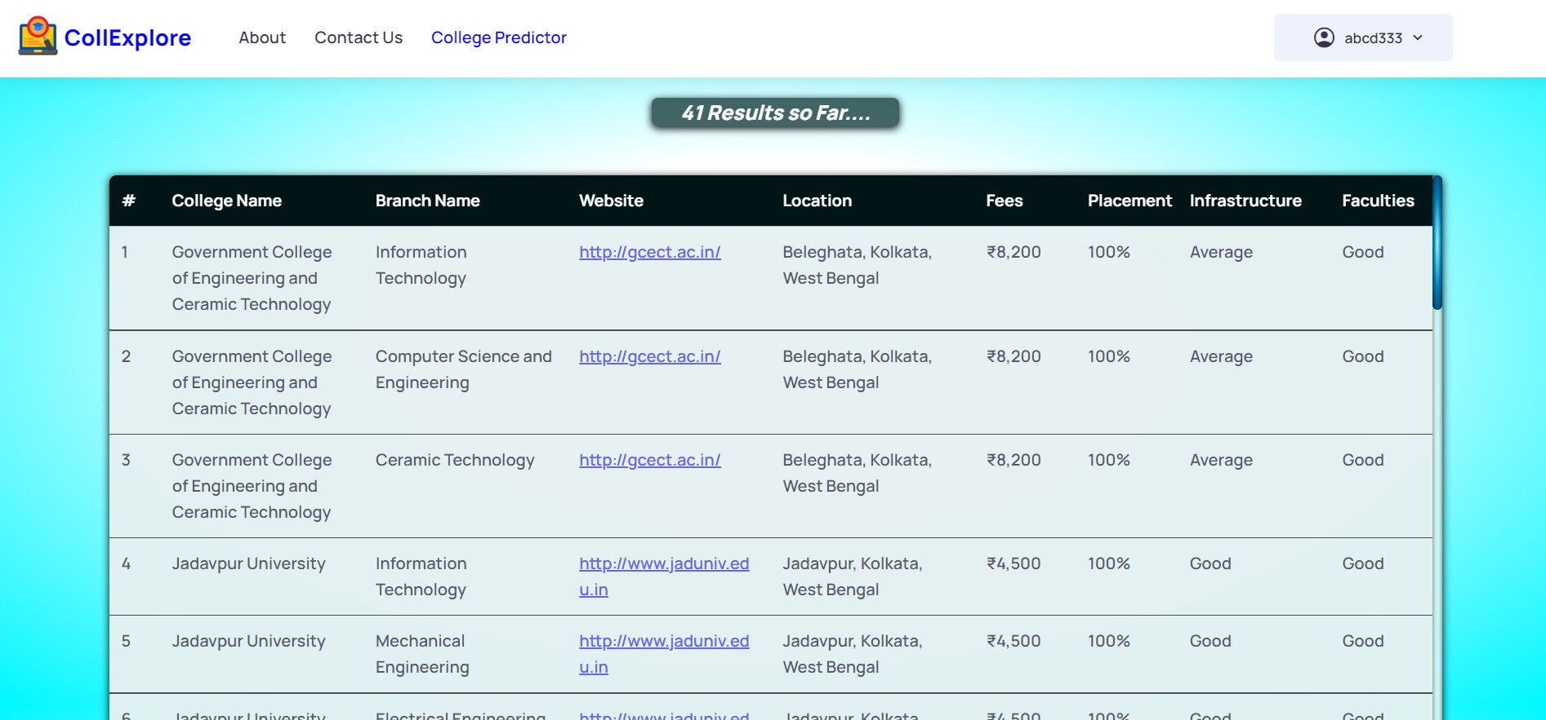**Only Score Entered:**
* **Score + Branch Entered:**

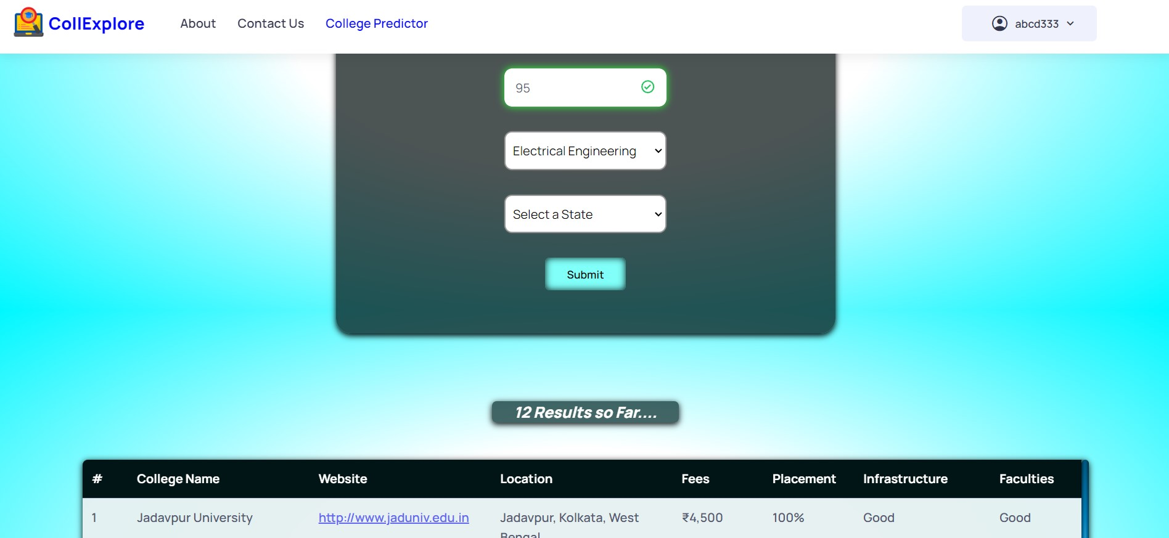**\*\***Here, Branch Column won’t be shown as it is already selected !

* 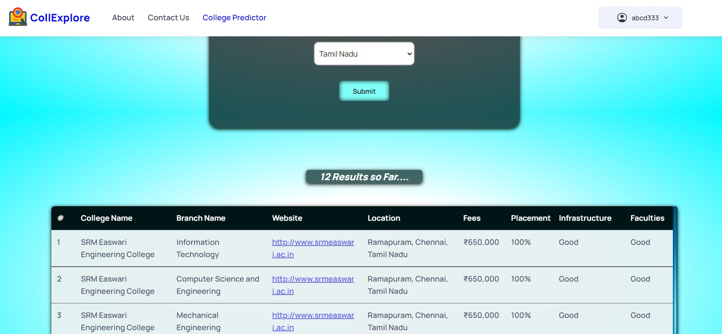**Score + State Entered:-**
* 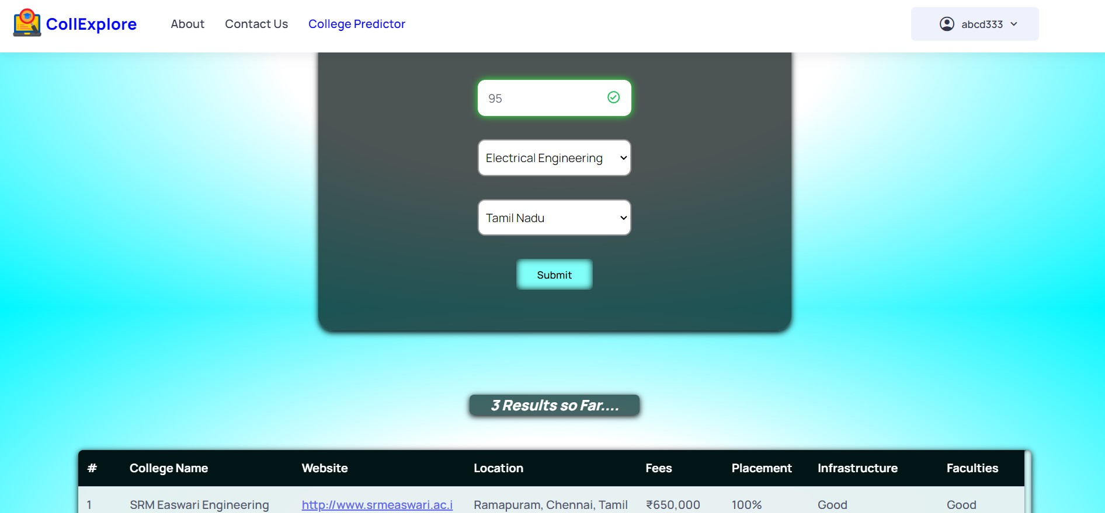**Score + Branch + State Entered:**
* “**No Results Found**” – If no output is returned !

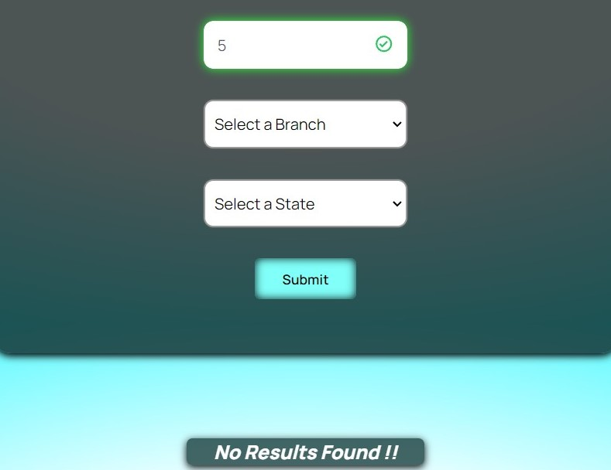

* **Error Message** will be displayed if user leaves out Score Field requesting user to enter their JEE Score and if the user has entered a Score **beyond the asked range**, in both the cases, a RED Border will get toggled up:-

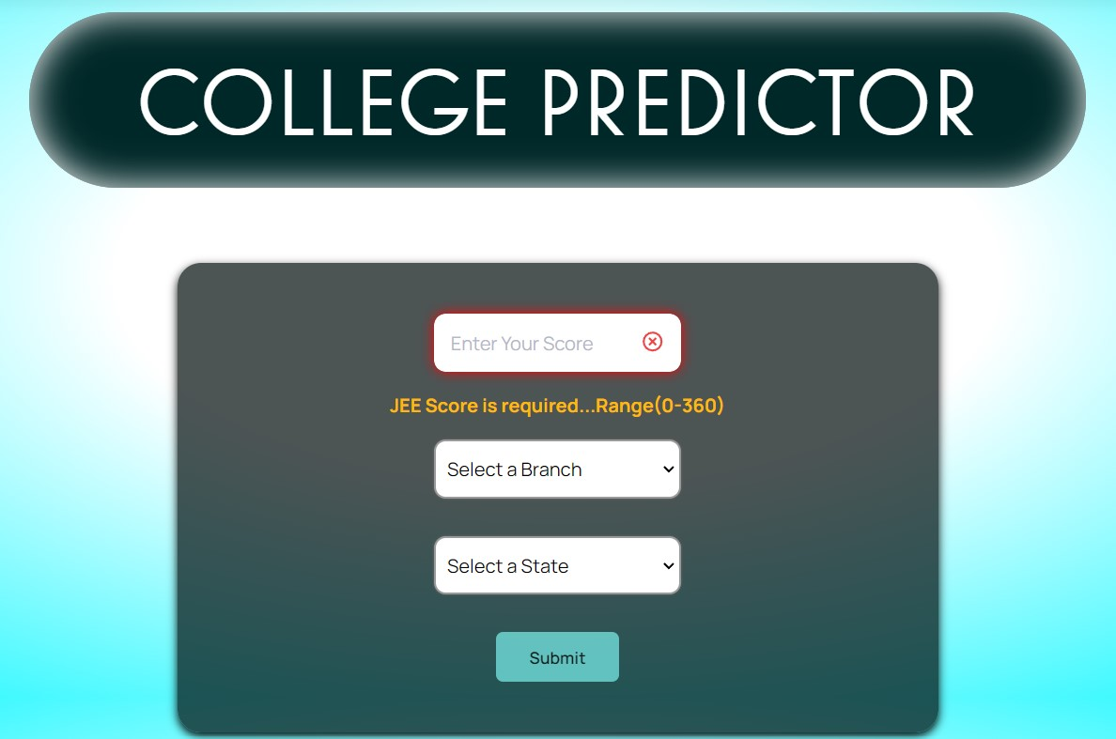

1. 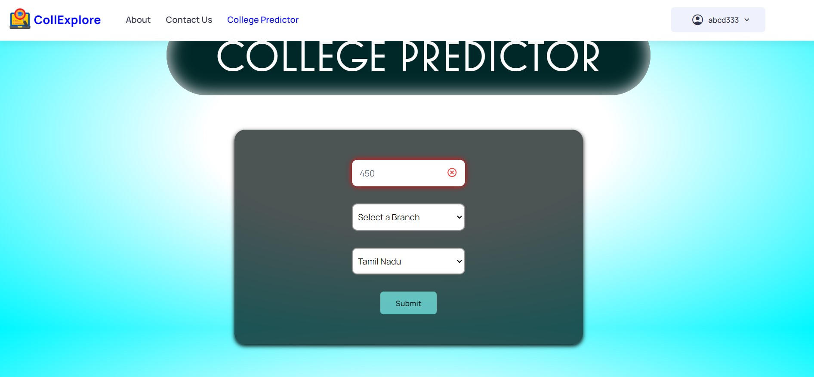A User on/after Logging Out will be redirected to Home-Page or Landing Page.

**Conclusion:-**

CollExplore and every feature has been made minutely, by keeping in mind about the experience of an user(Student(s) in this case) visiting this page for acquiring information about colleges present in or beyond a particular area. We believe that this product will help students to find better Engineering colleges and make their college selection process much easier through precise information which is been provided. Our product is built on the premise that students should be able to make informed decisions about their futures based on their scores, which are derived from their educational background and other factors. And, thus, our vision is to up the game of this web application by upgrading and adding different features from User(s) Perspective.